Checklist of Documents Required for H4 transfer (Spouse)

- Documents MUST be in .pdf format or zip file in ONE email.
NO MULTIPLE EMAILS.
- Documents MUST be in ONE SINGLE .ZIP FOLDER.
NO MULTIPLE FOLDERS.
- Documents MUST be CLEARLY NAMED – See Example Below

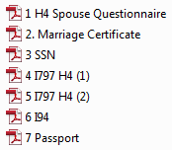

Document
Order
Example

- H4 Spouse Questionnaire
- Copy of Social Security Card / ITIN Number (If Applicable)
- Marriage Certificate
- H4 Approval I-797
- Copy of full passport (please include blank pages), including current I-94 including front and back.
RANDSTAD TECHNOLOGIES H4 SPOUSE VISA QUESTIONNAIRE

- Your Full Legal Name First:_________________________________________________
Middle Name: ____________________________________________________________
Last Name: ______________________________________________________________

- Any other names used, including maiden name:_______________________________________
- Gender ⁭ Male ⁭ Female
- Present address:_________________________________________________________________
- Present telephone numbers: Home__________________ Cell ____________________
- Email Address: _________________________________
- Date of Birth:_____________
- Place of Birth (City, Province & Country): ________________________
- Please provide your social security number (if applicable):_________________________
- Address and telephone number of residence abroad: (Important to complete)
  - _______________________________________________________________________
  - _______________________________________________________________________
  - Tel number of residence abroad: ____________________________________________

- When did you land in the US for the 1st time and on what visa? ______________________________
12. Have you worked while in the US ? Yes ____ No _____ If yes, please provide the following:
1) Copy of your employment authorization card
2) Most recent paystub(s)
3) Name of employer
4) Address of employer
5) Weekly income

IMPORTANT NOTE:
Please note that it is important that you (and your H-4 dependents, if applicable) be physically present in the United States when your H-1B/H-4 extensions are filed. It is not possible to file an extension of stay if you are outside the US. Therefore, please ensure to notify us of any travel plans you have while your petition is being prepared for filing.

Please list ALL your periods of stay in the United States. Please list only those periods in which you were ACTUALLY IN the United States:

Period of Stay (mm/dd/yyyy): Status:

From: _____________________ To: __________________
From: _____________________ To: __________________
From: _____________________ To: __________________
____________________________________ ______________________________
Signature Date

IMPORTANT

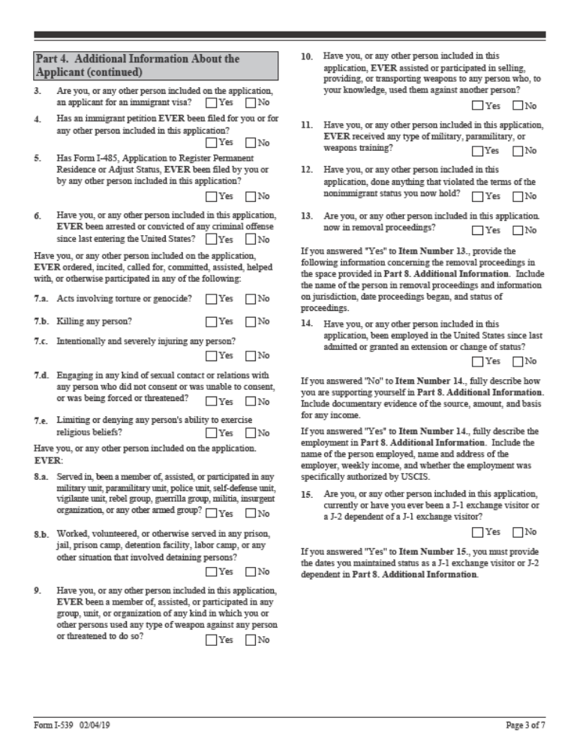As part of the I-539 Form, USCIS requires that the dependent answer several questions related to their background. Attached please find page 3 of the form. The dependent should answer each question with a pen and include this page with the documentation submitted for the preparation of the forms.

